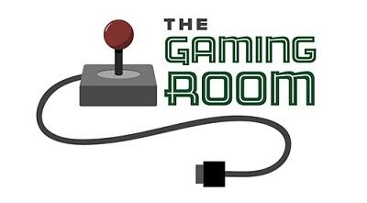
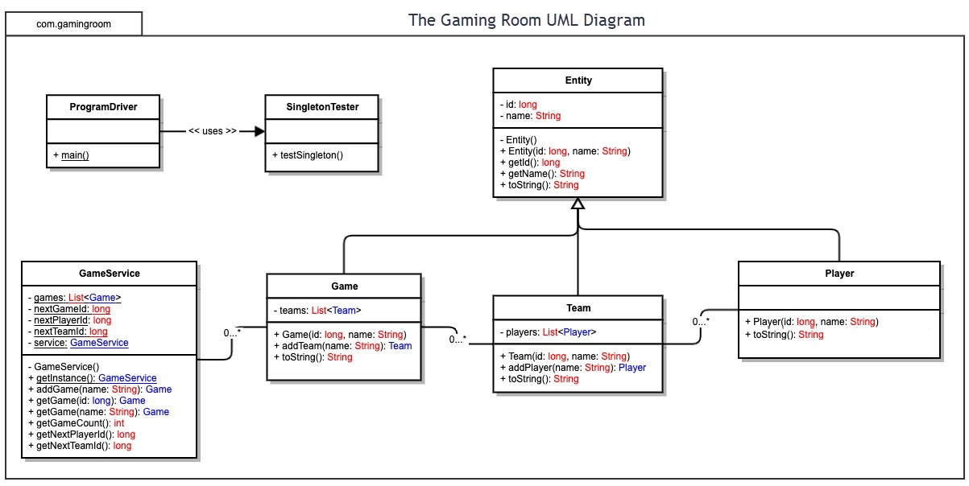

<Name-of-Software-Application>

CS 230 Project Software Design Template
Version 1.0

Table of Contents

1.CS 230 Project Software Design Template 1
Table of Contents 2
Document Revision History 2
Executive Summary 3
Design Constraints 3
System Architecture View 3
Domain Model 3
Evaluation 3
Recommendations 5
2.Operating Platform: <Recommend an appropriate operating platform that will allow The Gaming Room to expand Draw It or Lose It to other computing environments.> 5
3.Operating Systems Architectures: <Describe the details of the chosen operating platform architectures.> 5
4.Storage Management: <Identify an appropriate storage management system to be used with the recommended operating platform.> 5
5.Memory Management: <Explain how the recommended operating platform uses memory management techniques for the Draw It or Lose It software.> 5
6.Distributed Systems and Networks: <Knowing that the client would like Draw It or Lose It to communicate between various platforms, explain how this may be accomplished with distributed software and the network that connects the devices. Consider the dependencies between the components within the distributed systems and networks (connectivity, outages, and so on).> 5
7.Security: <Security is a must-have for the client. Explain how to protect user information on and between various platforms. Consider the user protection and security capabilities of the recommended operating platform.> 5

Document Revision History

Version | Date | Author | Comments
1.0 | 09/19/2021 | Chris Dechene | Updated to incluide summary for CTS

Instructions
Fill in all bracketed information on page one (the cover page), in the Document Revision History table, and below each header. Under each header, remove the bracketed prompt and write your own paragraph response covering the indicated information.

Executive Summary

The client requires the game to have the ability to have one or more teams involved in the game. The teams will have multiple players assigned to them. The client requires that only one instance of the game can exist in the memory at any given time. The other requirement is that the client wants the game and team names to be unique in that users can check whether or not the name is in use when choosing a team name.

Design Constraints

Each game needs to be unique and stored in the same game service. There can only be one single game service in the code. There cannot be two teams of the same name as well as two players of the same name. For example there cannot be two “Team Red” if one “Team Red” is created then it is stored. Another team must have a different name in the game. I need to implement a check for a unique team and player names.

System Architecture View

Please note: There is nothing required here for these projects, but this section serves as a reminder that describing the system and subsystem architecture present in the application, including physical components or tiers, may be required for other projects. A logical topology of the communication and storage aspects is also necessary to understand the overall architecture and should be provided.

Domain Model

The Entity class is the main parent class while the Game/Team/Player class all extend from it. This is an example of inheritance as it extends the getId long and getName String to each child class in the model. This also extends into the GameService for adding in the player name and team id as well. Every class pulls from the Entity class. Encapsulation is another OOP concept shown in the UML diagram. There are multiple variable especailly in the GameService class that are labeled as private. These fields cannot be accessed outside of the class. These fields are made in each class and then there are the public setters and getters in each class that can be modified. These would be the players and teams that need to be modified and stored in order for the game to function as intended.

Evaluation

Using your experience to evaluate the characteristics, advantages, and weaknesses of each operating platform (Linux, Mac, and Windows) as well as mobile devices, consider the requirements outlined below and articulate your findings for each. As you complete the table, keep in mind your client’s requirements and look at the situation holistically, as it all has to work together.

In each cell, remove the bracketed prompt and write your own paragraph response covering the indicated information.

Development Requirements | Mac | Linux | Windows | Mobile Devices
Server Side | Pro: Standard Java Runtime is compatible.  Con: Macs are expensive systems ranging from $900 onwards.  Con: Mac OS X can only be run on Apple products  Pro: Mac OS X is included with Macs  Pro: Apple trained support staff is common and can be hired | Pro: Linux OS is free and open source.  Pro: Linux can be installed on windows PCSs (and Mac PCs too)  Con: Linux has no standard edition of OS like Mac and Windows  Con: Staff will need to be trained or hired to support | Pro: Windows PCs can be much more affordable  Pro: Well known OS and widely used  Con: PCs without Windows 10 need to pay to upgrade  Con: Windows 10 Pro for Workstations is $309 per OS and just regular W10 Pro is still $199.99 | Con: Mobile devices can only connect through wireless internet or needs to have cell phone service  Pro: Phones can be affordable systems  Pro: Android and iOS comes with devices and can be upgraded at no cost  Pro: Mobile app developers are avalible to be hired.
Client Side | Pro: Mac comes installed with Safari which has ease of use an access and supports JavaScript and HTML | Pro: Firefox is included in Linux and supports Javascript and HTML | Pro: Microsoft Edge is widely accesable and supports JavaScript and HTML | Pro: Android and iOS browsers support Javascript and HTML
Development Tools | Pro: Mac OS X is based on Apache web server  Pro: Can debug both iOS and Android devices  Pro: Safari includes web development tools like Web Inspector  Con: Apple Developer Program is $99 a year | Pro: Open source software so no need for approval or cost  Pro: Linux uses Apache which supports Javascript and HTML  Con: Updating process can be complex  Con: Team would need experience with Linux | Pro:Windows Visual Studio IDE software is free  Con: Windows VS is also avalible on Mac and Linux  Pro: Microsoft IIS supports JavaScript and HTML  Con: While Microsoft provides support and upgrades they are not free of charge | Con: Mobile apps needs approval from Apple App Store and or Google Play  Pro: React Native is an open source mobile app development tool that can be used for both Android and iOS. It uses a JavaScript library for building user interfaces.

Recommendations

Analyze the characteristics of and techniques specific to various systems architectures and make a recommendation to The Gaming Room. Specifically, address the following:

Operating Platform: My reccomendaton for an operation platform would be Microsoft Azure as the operating platform.

Operating Systems Architectures: Azure implements virtaul machines and these run in an Azure hypervisor, which is not accessible to the public. The hypervisor divides a node into a variable number of guest Vms, each node has one root of Vmm which runs the host operating system. Windows Firewall is enabled on each VM. All traffic and access to the disk and network is mediated by the hypervisor and root operating system.

Storage Management: For Microsoft Azure there is the Azure Storage Explorer. This is Azure's cloud storage management solution which is designed to work in tandem with Azure.

Memory Management: Azure uses Virtual Memory allocation and placement on Azure Stack for memory management. In AS, a scale unit provides the avalibiltiy of resources, this consists of AS servers that are reffered to as hosts or nodes. The infastructure is in a set of VMs and share the same physical servers as the tenant Vms. The scale unit simplifies the management Azure Stack.

Distributed Systems and Networks: Azure uses client-server architecture to connect to end users. The clients must present “user access tokens” to access communication services remotely. We would need to create these so our users can access our servers. In the case of a server crashing or going down having multiple servers in different areas can help remedy this possibility. If there is only one server then if it goes down then the whole game will as well.

Security: I recommend for security “the prinicple of least privilege” for users to protect the OS from being compromised. For the users on the database they need to connect to the server with a user id and password and then the authenticator would vertify the id/passsword and then match the role indicated with that user to enable and limit what they can do in the software. A simple “user” can be locked out of many options that an “admin” would otherwise have access to. This limits any potential damage that could be done to a server and will give time to track and shut down if there is a possible breach.

